***Google Sites***

Link: <https://sites.google.com/maju.edu.pk/bar-b-q-tonight1/home>

Screenshot:

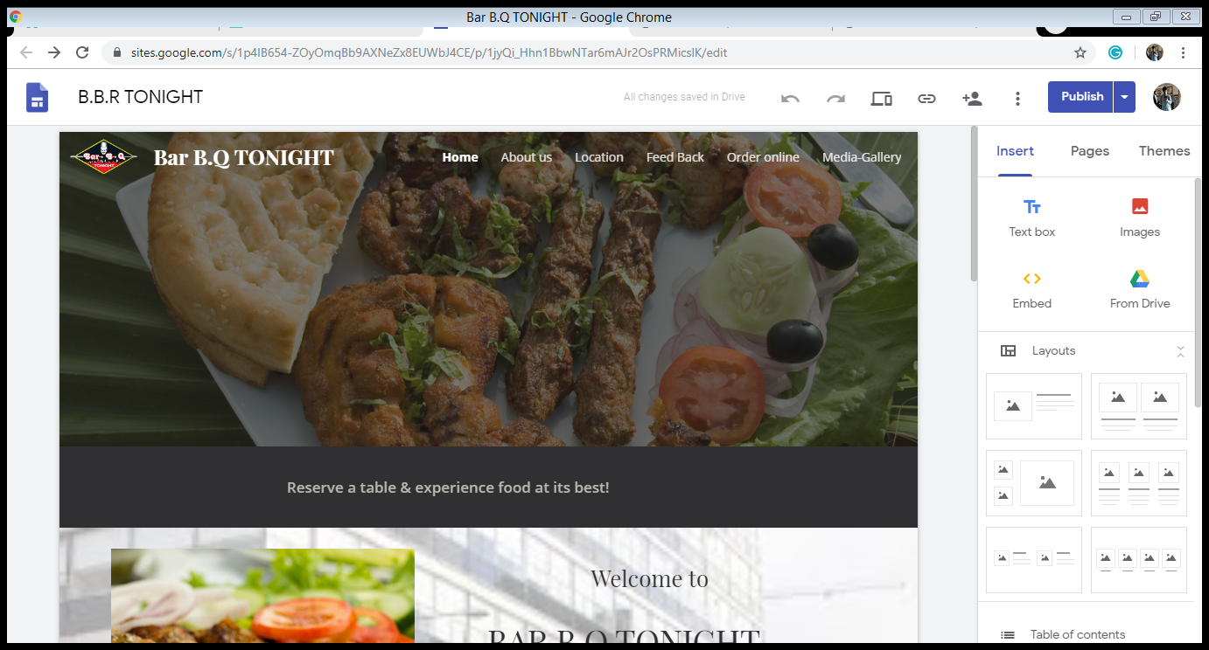\

***Google Form***

Link: https://docs.google.com/forms/d/e/1FAIpQLSdYQm3gFRA5GzRbVx5Z1TQgUR1Y-gTUIoB0j3TZrjN4j0qMcw/viewform?usp=sf_link

Screenshot: 